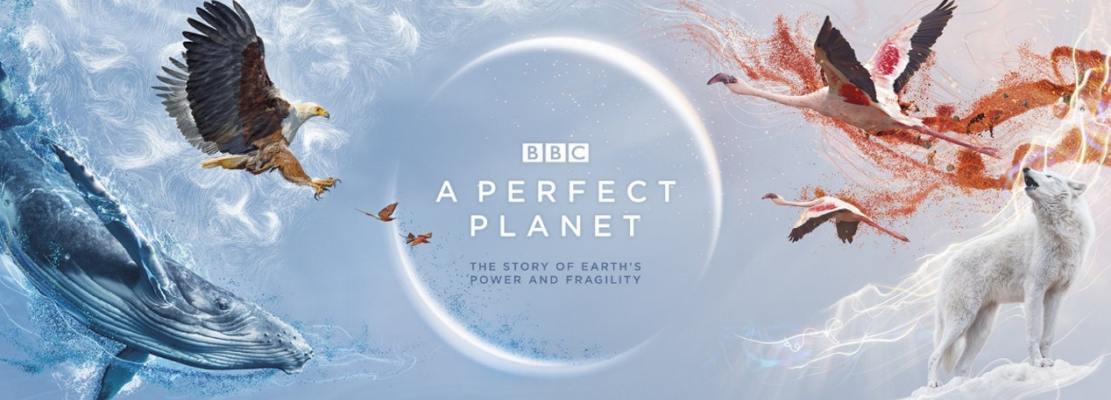

A Perfect Planet Episode 1

1. What is the focus of this fist episode?
2. What natural forces allow life to flourish on Earth?
3. How many active volcanos are there in the world today?
4. The most active volcano is named what? And where can it be found?
5. What is the liquid rock from a volcano called when it is below the Earth’s surface?
6. What is the liquid rock from a volcano called when it is above the Earth’s surface?
7. The active volcano in Tanzania is named what?
8. How many times has it erupted in the last 100 years?
9. What is unique about Lake Natron?
10. What type of bird nests in Lake Natron?
11. What substance turns the Flamingo’s feathers pink (it also colours their eyes)?
12. 80% of the Earth’s surface is the result of what?
13. Which is the youngest island in the Galapagos Archipelago?
14. How does the volcano help with the Iguanas eggs?
15. Volcanic islands make up 5% of the planets land but are home to what percentage of its species?
16. How have the Finches on Wolf island adapted to survive without traditional food available?
17. Describe the features of an atoll?
18. How might climate change impact Giant Tortoises at Aldabra?
19. The volcano in the middle of North America is called what?
20. What benefit does living near a Geyser bring River Otters at Yellowstone?
21. The Kamchatka Peninsula lies along a fault line, and has the most geysers in the world, which animal takes advantage of the consequences of the heat the geysers provide?
22. What is the name of the lake where the Bears fish for Salmon?
23. A single ash cloud from a volcano can carry what?
24. Which gas was first brought up by volcanos from deep within the Earth’s crust?
25. Human beings release how much more Carbon Dioxide than all the volcanos on earth combined?